**WEBSITE DEVELOPEMENT PROPOSAL**

OBJECTIVE : The purpose of this website should be a combination of characteristics of a b2b, forum and informative website

AIM : Supply Buyers, Suppliers, Traders, Intermediaries, Freight Forwarders, Business Advocates with sufficient information and create a platform for them to come together, talk business and develop their trade, meanwhile at the same time we mediate for trades and build successful clientele base.

PROSPECT : Build a functional website, run with manufactures and suppliers internationally and have a database of all legit suppliers, build an App and gain atleast a million members

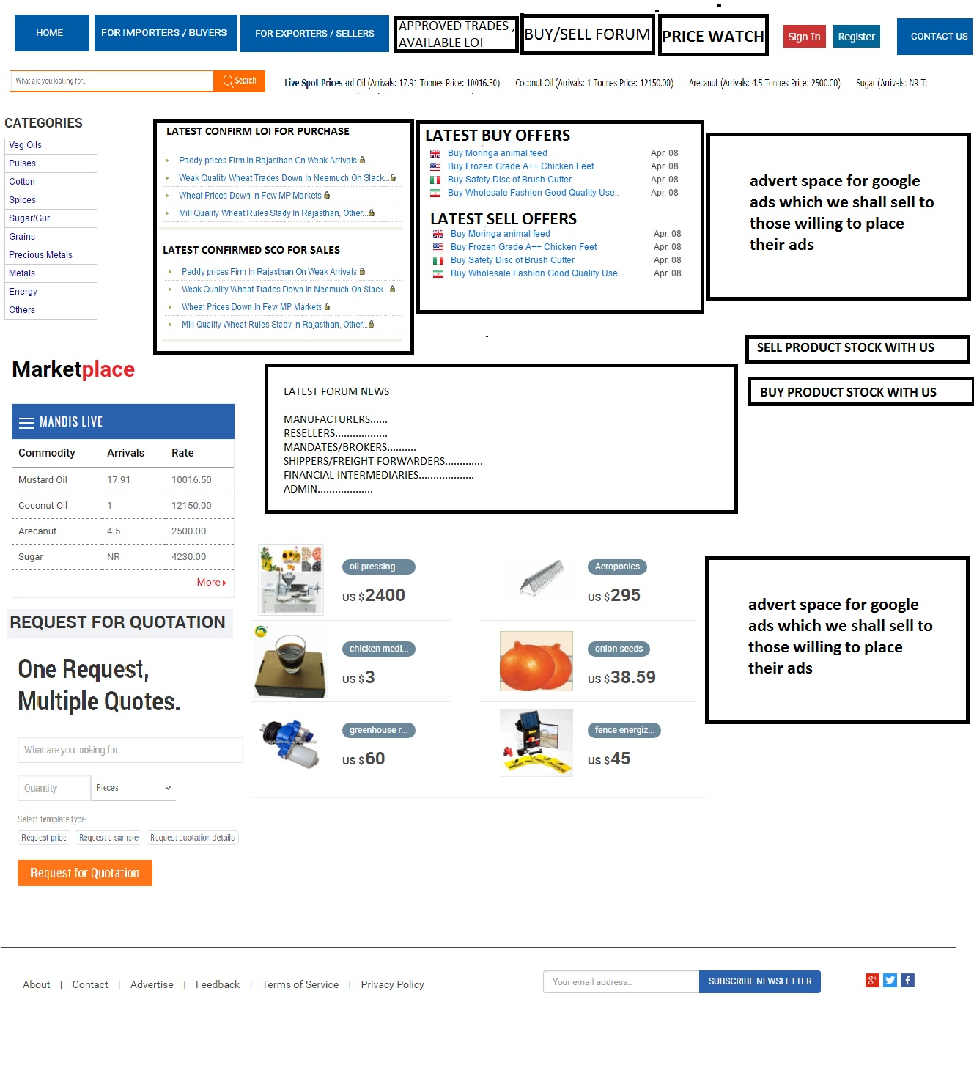EXAMPLE OF SITE OVERVIEW

EXPLANATION OF SITE OVERVIEW

HOME : Home should redirect to this main page and have all these features on display

FOR IMPORTERS / BUYERS : This page will most importantly contain a form, which buyers or importers can fill to send to us an exact message of what their buy requirement or what they want to buy is , this message will be sent to us and will not be displayed on the website, we shall review and contact them, before we can place on the site, such as

*PRODUCT NAME…………………………………..*

*QUANTITY…………………………………………..*

*DESTINATION………………………………………*

*REQUIRED PACKING………………………………*

*REQUIRED TRADE TERM……………………..*

*CONTACT NAME…………………………………*

*CONTACT EMAIL……………………………………..*

*CONTACT PHONE NUMBER……………………..*

*COMPANY NAME……………………………………….*

FOR EXPORTERS / SELLERS : This page will most importantly contain a form, which sellers or exporters can fill to send to us an exact message of what their sell requirement or what they want to sell is ,this message will be sent to us and will not be displayed on the website, we shall review and contact them, before we can place on the site, such as

*PRODUCT NAME…………………………………..*

*QUANTITY…………………………………………..*

*ORIGIN………………………………………*

*PACKING………………………………*

*ACCEPTABLE TRADE TERM……………………..*

*CONTACT NAME…………………………………*

*CONTACT EMAIL……………………………………..*

*CONTACT PHONE NUMBER……………………..*

*COMPANY NAME……………………………………….*

APPROVED TRADES, AVAILABLE LOI : This page will contact a brief description of various buy offers which we have verified and authenticated, then we shall list the list them with brief description, then you can click to read more details, we shall also have space to upload a few photos or documents per LOI ( letter of intent )

APPROVED TRADES, AVAILABLE SCO : This page will contact a brief description of various sell offers which we have verified and authenticated, then we shall list the list them with brief description, then you can click to read more details, we shall also have space to upload a few photos or documents per SCO ( soft corporate offer)

BUY / SELL FORUM : This is a forum that will be divided into the following categories

*MANUFACTURERS..*

*RESELLERS / BUYERS/ SELLERS...*

*MANDATES / BROKERS...*

*SHIPPER / FREIGHT FORWARDERS...*

*FINANCIAL INTERMEDIARIES*

*MESSAGE TO ADMIN....*

No one will be allowed to post email address or websites into this forum, only the admin can do that

People can discuss trade affairs in the various categories

This forum will be constantly monitored for scam and hack activities, any fishy member will be immediately blocked

REGISTER : You must register to be a member , to protect the site from spammers, scammers, hackers and illicit activities

SIGN IN : You must sign in to use any of our service, but the display is open for any one to browse, you must sign in before you can read more or contact

PRICE WATCH : This page contains plugins or graphs that give us updated price of commodities worldwide per day, you can search this page and see international market price or range for almost or all commodities worldwide, we shall need to install plugins that collect data from different sites or price watches and display on our site, this info is updated daily, either by us or plug in or site we are refereeing from

CARTEGORIES : This is a list of all commodities in various classification such as

*VEGETABLE OILS*

*PULSES AND BEANS*

*SPICES*

*GRAINS*

*SUGAR AND SALT*

*METALS*

*ENERGY*

*ELECTRONICS*

*WASTE ARTICLES.*

*....*

*.*

This will list just like 20 categories, then you can click and browse all various categories ,when you click or pop up should open, where you can search by category or you can input product name and it will take you to category or pages you are looking for, this is for search purpose, to take you to your required page you are searching for information, this we shall need to properly compile all categories that are easily accessible as per products and details required.

LATEST CONFIRMED LOI FOR PUCHASE : This is just a run up of adverts of the latest updated LOI’s within 24 hours of that day, it carries just a header of the LOI like beginning statement and product name

LATEST CONFIRMED SCO FOR SALES : This is just a run up of adverts of the latest updated SCO’s within 24 hours of that day, it carries just a header of the SCO like beginning statement and product name

LATEST BUY OFFERS : This is just a run up of adverts of the latest updated buy offers from buyers / importers, it carries just a header of the buy offer like beginning statement and product name

LATEST SELL OFFERS : This is just a run up of adverts of the latest updated buy offers from sellers / exporters, it carries just a header of the sell offer like beginning statement and product name

LATEST FORUM NEWS : This is a run up of latest post on forum as per various categories, this a header or beginning of the statement, latst news within the last 24 hours

SPACE FOR GOOGLE ADS : Place ads for clients selling on google,

DISPLAY PHOTOS : Display photos of premium members, which when clicked, links you to their page for contact, info sent will be directed to us, we access before passing over to the clients

MARKET PLACE : Clients online for live chat

REQUEST FOR QUOTATION : Send to us an urgent requirement to fast response

SEARCH BAR AND UPDATED PRICE RUN UP BAR ABOVE : As stated

WE INTEND TO HAVE ONLINE CHAT SERVICE, ADMIN ACCESSIBLE TO MORETHAN 10 - 30 , STAFF BUT WITH STRICT SECURITY PROTOCOL TO MAIN OFFICE

MORE DETAILS WILL BE ADDED AS THIS PROJECT IS ON GOING